**Institute of Technology Tralee**

**BSc. in Computing with Specialism (Group 4) - Year 1**

**Continuous Assessment #1**

**Date: 24/10/13**

**Time: 2 – 4p.m.**

**Introduction to Programming**

**Instructions:** Attempt the following question. You should use the JCreator IDE for coding. When you are finished you must print out your code for correction.

**________________________________________________________**

**Q1.**

A person entering a parking lot receives a ticket from a machine and when they leave the parking lot the machine takes the ticket, determines the amount of time spent parking and calculates the amount the customer must pay. It uses the following table of values in its calculations:

|  |  |
| --- | --- |
| **Time Spent Parking** | **Cost** |
| Up to and including 1 hour | 60c per hour |
| Next two hours | 50c per hour |
| Anything more | 40c per hour |

So, for example, if a person spends 1.5 hours in the parking lot, they must pay 60c for the 1st hour and 25c for the remaining half hour for a total of 85c.

Your program should define **constants** for the 3 different rates above.

The program should ensure that the time value entered is valid (greater than or equal to zero). If it is invalid, then an appropriate error message should be displayed and the program immediately terminates (without doing any calculations whatsoever).

Provided that the time value is valid, your program should display the total cost correct to **2 decimal places.**

Using the test values as indicated in the screen shots below, the program should give you **exactly** the following output when it runs, including banners, blank lines, units etc.

Also note that there will be a few marks awarded for the use of **meaningful variable names**, having a  **single and multi-line comment at the top of the program** and for **proper indentation** in the coding of the program.

**Sample Screen Shots**

**The user enters an invalid time value here**

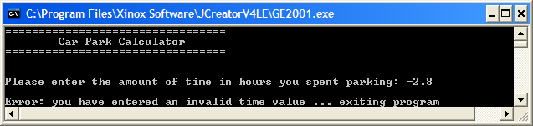

**The user enters a valid time value not greater than 1 hour**

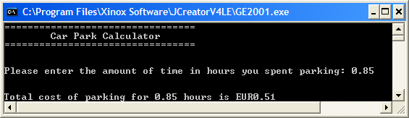

**The user enters a valid time value between 1 and 3 hours**

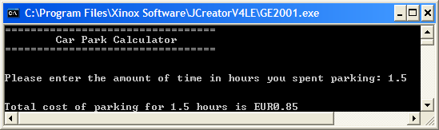

**The user enters a valid time value over 3 hours**

